

|  |  |  |  |  |  |  |  |  |
| --- | --- | --- | --- | --- | --- | --- | --- | --- |
|  | | | | | | | | |
|  | | Capstone Project – Weather Analysis | | | | |  | |
|  |  | | | | | | |  |
|  | | | |  |  | | | |
|  | | | | Devesh Danthara |  | | | |
|  | | | | —Data Analytics: DA11—Devesh Danthara |  | | | |
|  | | |  | | |  | | |

|  |  |  |  |  |  |  |  |  |
| --- | --- | --- | --- | --- | --- | --- | --- | --- |
|  |  | | |  |  | | |  |
|  | Overview | | | | | | |  |
|  |  | | |  |  | | |  |
|  |  | |  | | |  | |  |
|  |  |  | The dataset provides an extensive overview of weather conditions across multiple cities worldwide, capturing data over time on various meteorological parameters. It includes granular details on temperature, humidity, wind speed, wind direction, pressure, and descriptive weather events. Additionally, the dataset has been meticulously structured to highlight city-level trends, monthly averages, and extreme weather occurrences, enabling an in-depth exploration of patterns and anomalies influenced by natural and climatic factors. | | |  |  |  |
|  | | | | |
|  |  |  |  |
|  |  |



|  |  |  |  |  |  |  |
| --- | --- | --- | --- | --- | --- | --- |
|  | |  |  |  |  | |
|  | | THE PROCESS | | |  | |
|  | |  |  |  |  | |
|  | 1. Data Acquisition from GitHub:  Obtain the requisite dataset from a designated GitHub repository, containing essential information on university rankings, encompassing various countries and their performance across distinct ranking systems.  2. Data Transformation and Enhancement:  If necessary, execute data transformation procedures to ensure data quality and consistency. Additionally, consider augmenting the dataset with new problem statements to enrich the analysis potential.  3. Connecting with Tools:  Establish connections between the dataset and various analytical tools. Interface the dataset with Power BI, Excel, and MySQL Workbench, facilitating seamless data integration and processing.  4. Problem Statement Solution in Power BI:  Utilize Power BI to delve into the specified problem statements. Employ its robust features for data visualization, exploration, and analysis, effectively deriving insights and solutions.  5. Exploratory Data Analysis (EDA):  Perform exploratory data analysis using either Excel or SQL Workbench, depending on the complexity of the analysis. Extract meaningful patterns, relationships, and trends from the data to inform subsequent decision-making.  6. Creation of Visual and Insightful PowerPoint:    Develop a comprehensive PowerPoint presentation that encapsulates the project's objectives, methodologies, problem statement solutions, and key visualizations. Each problem statement should be accompanied by a dedicated section with pertinent conclusions and insights.  7. Detailed Documentation:  Compile a detailed report that meticulously documents the entire project lifecycle. Include sections on data collection, transformation, problem statement formulation, tools integration, Power BI solutions, EDA insights, and PowerPoint visualizations. | | | | |  | |

# Objective

The primary objective of this project is to perform an in-depth exploratory data analysis (EDA) of weather patterns across various cities to uncover insights into climatic trends, anomalies, and their potential implications. Specific goals include:

1. **Identifying Weather Anomalies:** Detect temperature, wind speed, and other meteorological anomalies and assess their frequency and impact across different geographical regions.
2. **Analyzing City Clusters:** Explore and explain clustering patterns of cities based on geographical and weather-related attributes such as latitude, longitude, and climatic factors.
3. **Exploring Coastal City Trends:** Investigate the influence of wind speed and direction on weather-related events, particularly in coastal cities prone to extreme conditions.
4. **Understanding Monthly Patterns:** Analyze seasonal variations in temperature, humidity, and other factors to identify months with significant deviations or noteworthy weather phenomena.
5. **Supporting Climate Impact Studies:** Provide structured insights into how natural factors, such as wind or extreme conditions, may influence weather trends and urban planning.

This analysis aims to guide actionable strategies for disaster preparedness, urban planning, and climate adaptation.

# Significance

This project holds considerable significance due to its potential applications in various fields, including environmental studies, urban planning, and disaster management. The key areas of impact include:

1. **Climate Adaptation and Mitigation:**
   * The insights derived from identifying weather anomalies can guide cities in developing adaptive strategies to mitigate the effects of climate change.
   * Understanding the impact of extreme weather conditions aids in better preparation for future climatic shifts.
2. **Disaster Preparedness:**
   * Analyzing weather-related events in coastal cities helps identify areas prone to natural disasters like hurricanes or storms, enabling better disaster response planning.
   * Wind and temperature trends can aid in assessing the vulnerability of infrastructure and communities.
3. **Urban Planning and Sustainability:**
   * Identifying city clusters with similar weather characteristics can inform the development of localized policies for energy consumption, transportation, and housing.
   * The relationship between wind patterns and pollution dispersion provides insights for sustainable urban development.
4. **Academic and Research Contributions:**
   * The study provides a foundation for further research on climate-related trends and their impact on human life and ecosystems.
   * It enables comparisons between cities to uncover regional disparities and shared challenges.
5. **Data-Driven Policy Making:**
   * The structured dataset and derived insights allow policymakers to make informed decisions regarding resource allocation, infrastructure resilience, and environmental regulations.

# Data Dictionary

**BASE TABLES:**

* **City**
  + Description: The name of the city under observation.
  + Example: 'Vancouver', 'San Francisco', 'Miami'
* **Latitude**
  + Description: The latitude of the city, indicating its position relative to the equator.
  + Example: 49.2827 (for Vancouver)
* **Longitude**
  + Description: The longitude of the city, indicating its position relative to the Prime Meridian.
  + Example: -123.1216 (for Vancouver)
* **Temperature**
  + Description: The recorded temperature for the city over time. This can be used to analyze trends, anomalies, and seasonal variations.
  + Example: 15.2°C, 22.5°C
* **Humidity**
  + Description: The recorded humidity levels for the city. This is essential for understanding the climate's moisture content and can impact comfort and precipitation.
  + Example: 65%, 80%
* **Weather Description**
  + Description: A textual description of the weather conditions such as sunny, rainy, stormy, etc.
  + Example: 'Rain', 'Clear', 'Thunderstorm'
* **Wind Speed**
  + Description: The average wind speed recorded for the city. Wind speed is used to understand the potential severity of weather events like storms.
  + Example: 5.6 m/s, 3.2 m/s
* **Wind Direction**
  + Description: The average direction from which the wind is blowing. This helps in understanding weather patterns and their influence on the local climate.
  + Example: 180° (south), 90° (east)
* **Event Count**
  + Description: The total number of weather-related events such as storms, hurricanes, or tornadoes that occurred in the city over the observed time period.
  + Example: 10 (for San Francisco), 5 (for Miami)
* **Datetime**
  + Description: The timestamp indicating when the weather data (temperature, humidity, wind speed, etc.) was recorded.
  + Example: '2023-05-01 12:00:00'

**Unpivoted Views**

These views are created to reshape the data, allowing for more flexible querying:

* **humidity_unpivoted**
  + Description: Reshapes the humidity data by unpivoting the city-wise columns into a long format with a 'city' column and a 'humidity' column.
* **temperature_unpivoted**
  + Description: Reshapes the temperature data by unpivoting the city-wise columns into a long format with a 'city' column and a 'temperature' column.
* **wind_speed_unpivoted**
  + Description: Reshapes the wind speed data by unpivoting the city-wise columns into a long format with a 'city' column and a 'wind_speed' column.
* **weather_description_unpivoted**
  + Description: Reshapes the weather description data by unpivoting the city-wise columns into a long format with a 'city' column and a 'weather_description' column.

**Shortened Views**

These views aggregate the data to improve query performance:

* **shortened_humidity**
  + Description: Contains the average humidity values per city, calculated by month.
* **shortened_temperature**
  + Description: Contains the average temperature values per city, calculated by month.
* **shortened_wind_speed**
  + Description: Contains the average wind speed values per city, calculated by month.
* **shortened_wind_direction**
  + Description: Contains the average wind direction values per city, calculated by month.

This dictionary provides a detailed description of the dataset used in the weather analysis project, including information on the structure, attributes, and purpose of each table and view.

# ER Diagram

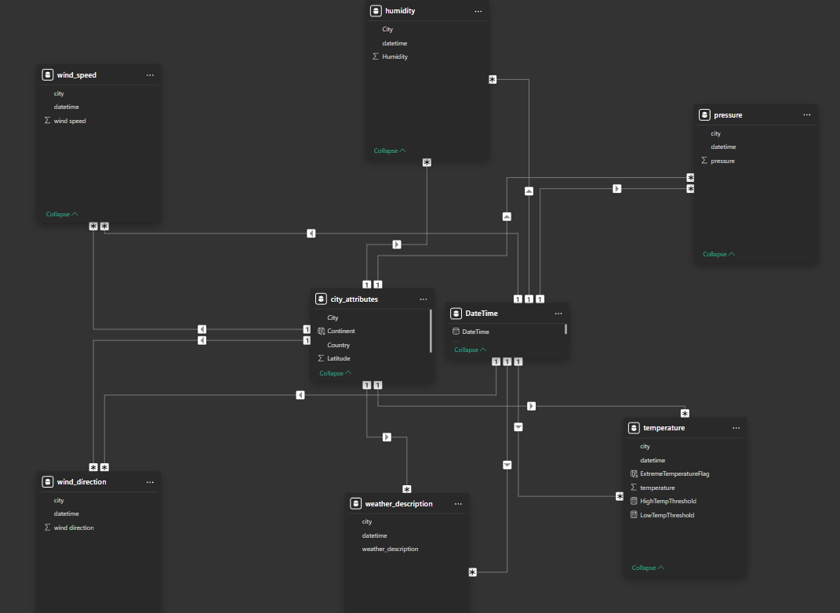

# POWERBI Report Overview:

**1. Geological Analysis**

* **Insight**: The cities analyzed span three countries—United States, Canada, and Israel—offering a diverse geographical context. This diversity allows for comparisons between arid (e.g., Beersheba) and coastal (e.g., Miami) regions, as well as temperate zones (e.g., Toronto). Such variability is critical for understanding how geography impacts weather patterns.

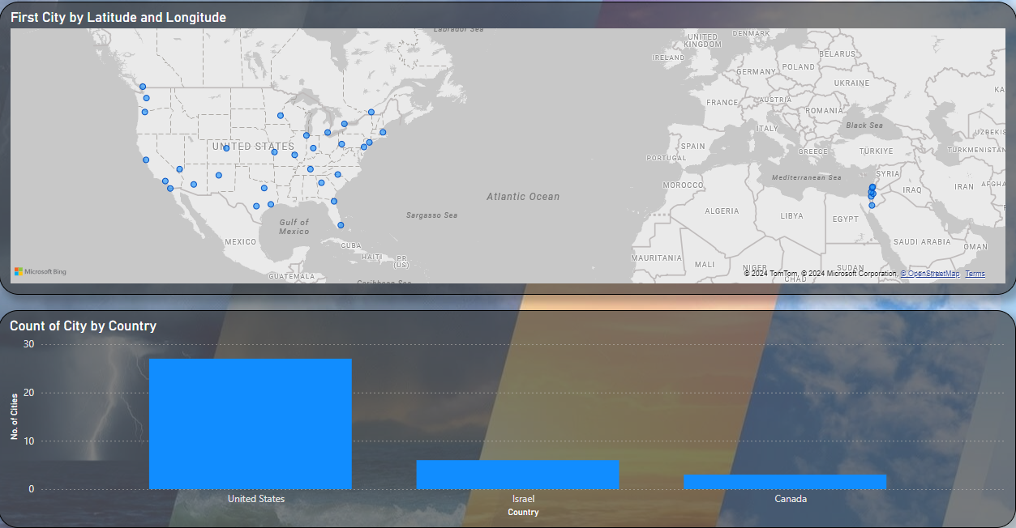

**2. Latitude and Longitude Mapping**

* **Insight**: This visualization highlights the distribution of cities across continents, with most cities clustered in North America. The map demonstrates the alignment of cities in proximity to coastal or inland areas, which likely influence their climatic characteristics. For example, coastal cities like Vancouver and Haifa show different weather patterns compared to inland cities like Las Vegas.

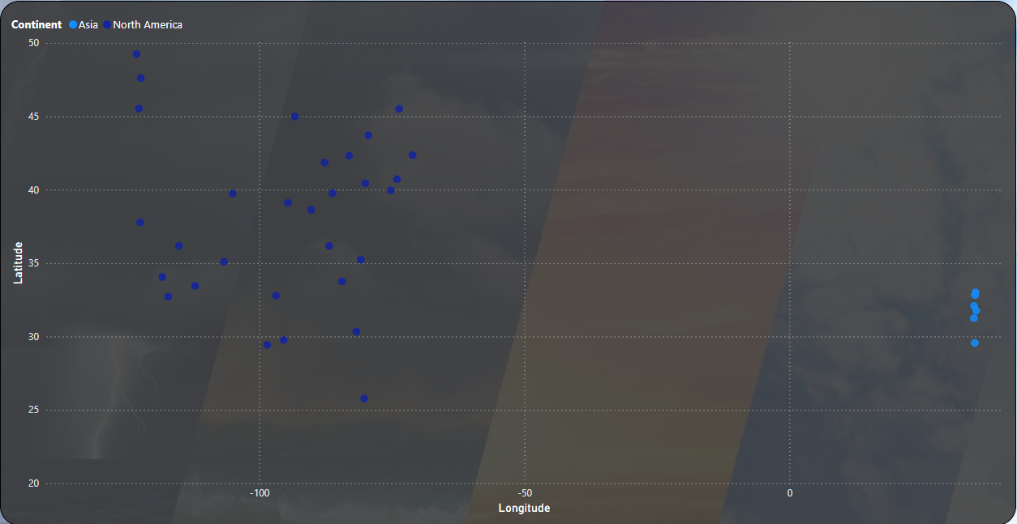

**3. Humidity Analysis**

* **Insight**: Average humidity levels provide an understanding of the atmospheric moisture differences across cities. For instance, coastal cities like Miami exhibit consistently higher humidity levels due to oceanic influence, while arid cities such as Las Vegas show much lower humidity. These insights help categorize cities based on their climate zones.

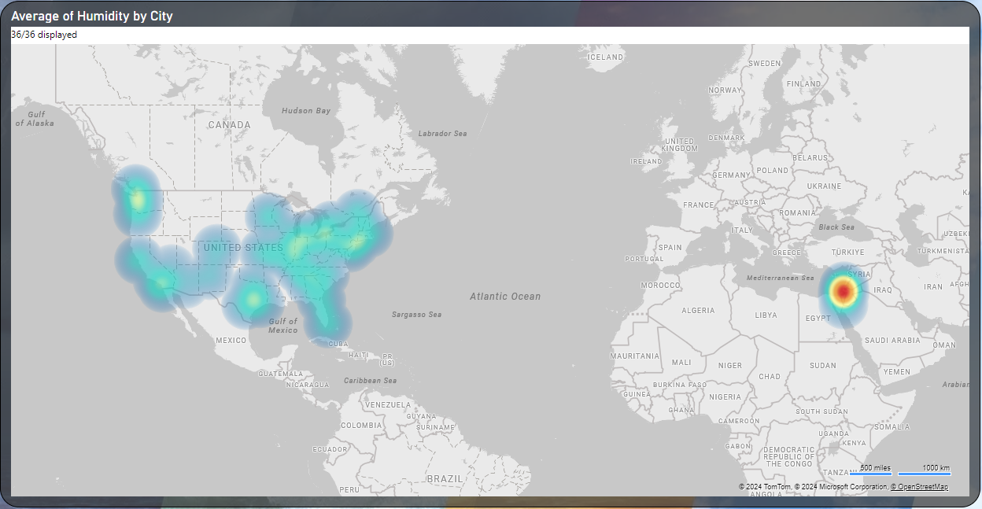

**4. Temperature Analysis**

* **Insight**: The temperature analysis reveals clear distinctions between extreme and normal temperature trends over the years. Cities like Phoenix and Las Vegas show high peaks in extreme temperatures, indicative of desert climates, whereas cities like San Francisco maintain moderate fluctuations, typical of coastal climates.

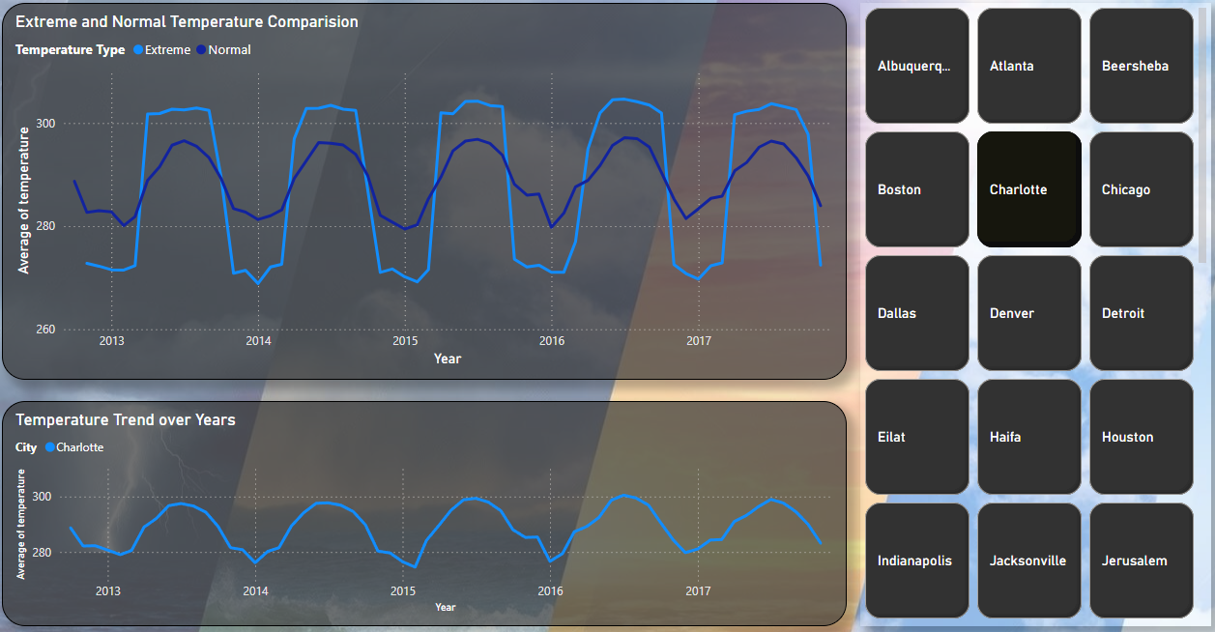

**5. Compare Two Cities on Temperature**

* **Insight**: Pairing cities such as Albuquerque and Atlanta highlights how geographical and climatic differences manifest in temperature trends. While Albuquerque shows wider fluctuations between seasons due to its high-altitude desert environment, Atlanta’s subtropical climate results in more consistent temperatures year-round. These comparisons provide a detailed look at how local factors drive weather conditions.

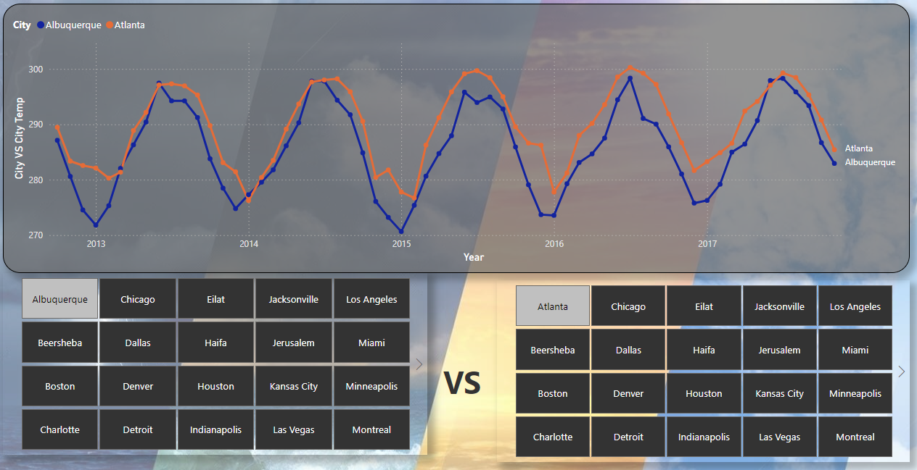

**6. Wind Speed vs. Pressure**

* **Insight**: A comparison of wind speed and atmospheric pressure over time shows a relationship where lower pressures often coincide with higher wind speeds, a common phenomenon during storms or weather disturbances. This insight can help predict stormy conditions or windy weather based on pressure trends.

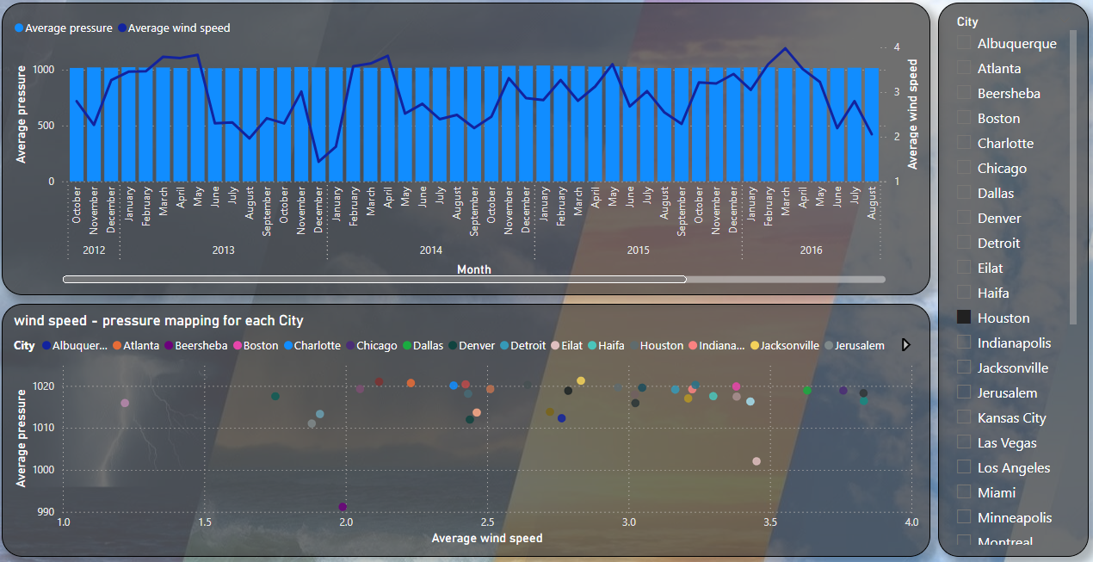

**7. Weather by Hour (Heat Map)**

* **Insight**: The hourly heat map demonstrates how certain weather conditions dominate during specific times of the day. For instance, "fog" is more common in early morning hours, likely due to temperature inversions, while "clear skies" are prevalent during midday hours. Such patterns provide valuable insights for planning activities or travel based on weather predictions.

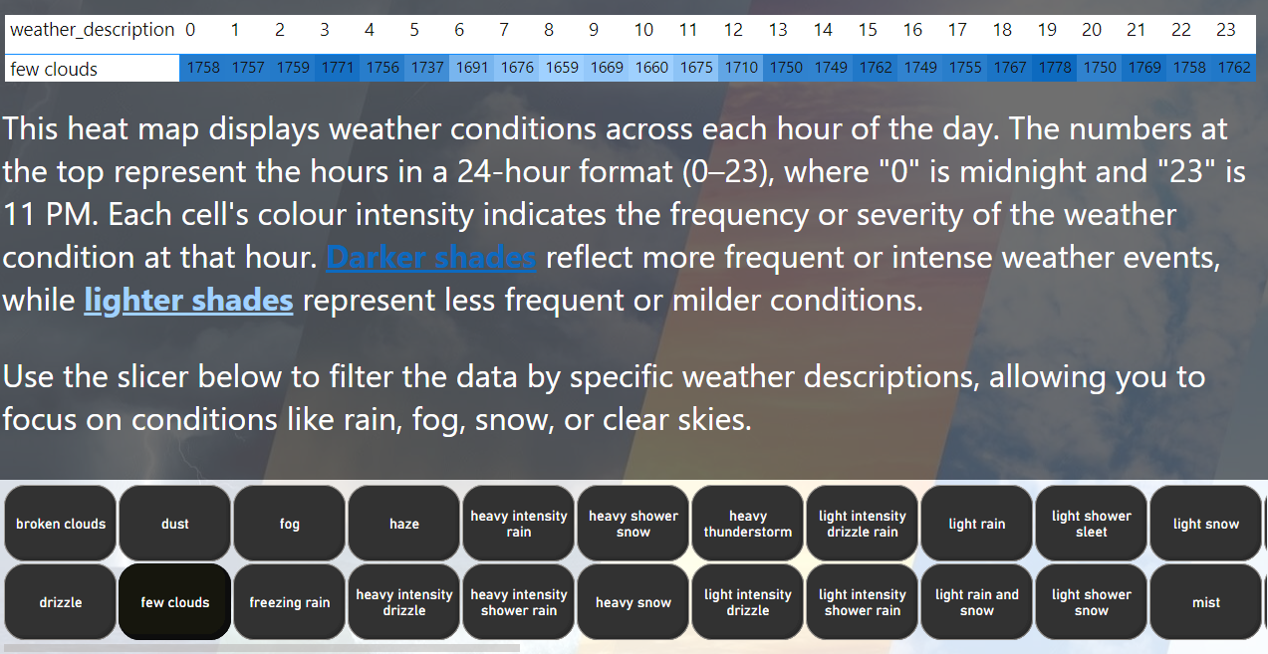

**8. Wind Analysis**

* **Insight**: Windrose charts reveal the dominant wind directions and their intensities for each city. For example, coastal cities may show consistent wind patterns from the ocean, while cities surrounded by mountains or deserts may experience more variable wind directions. These insights are crucial for industries like aviation and renewable energy.

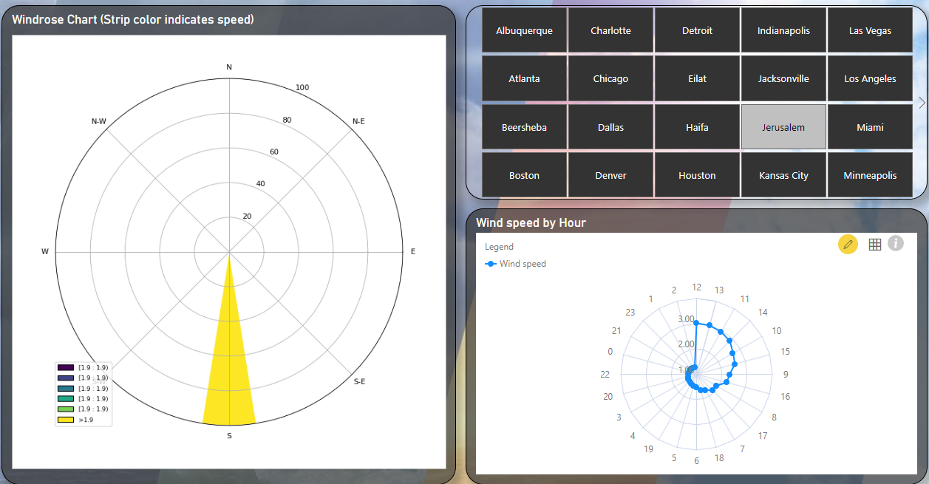

**9. Temperature vs. Humidity**

* **Insight**: A clear inverse relationship emerges between temperature and humidity for many cities. For example, desert cities like Las Vegas have high temperatures and low humidity, while tropical or coastal cities like Miami maintain high levels for both. These relationships are essential for understanding comfort levels and potential weather impacts on daily life.

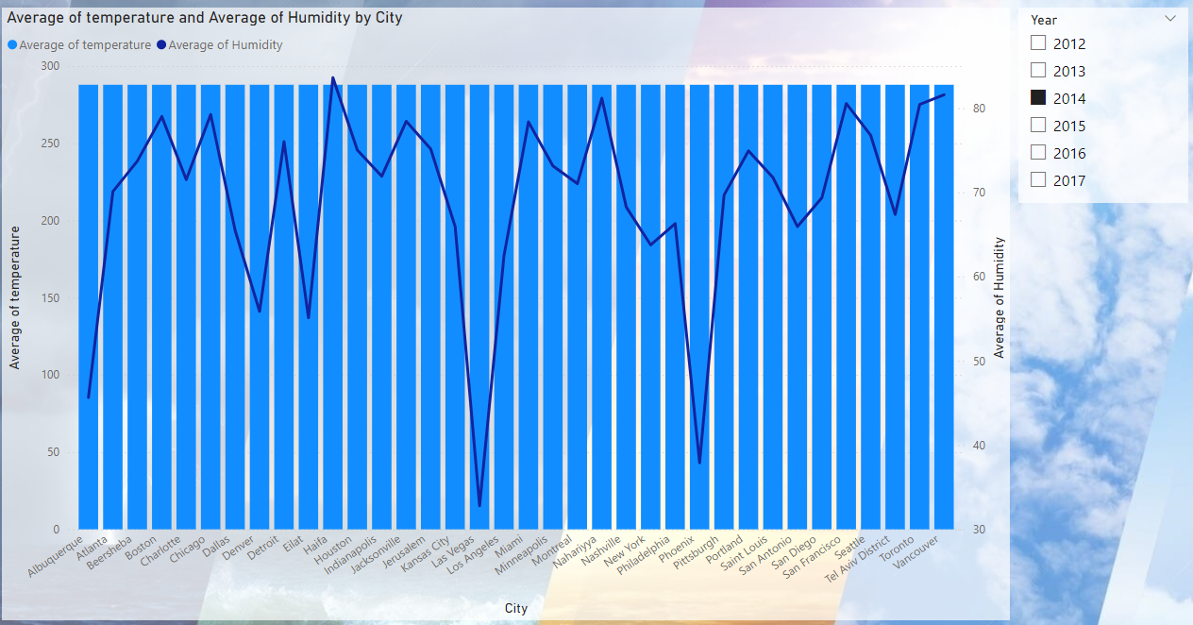

**10. Extreme and Normal Temperature Comparison**

* **Insight**: The analysis of extreme versus normal temperatures shows that some cities experience a significant number of extreme temperature days. For instance, desert cities like Phoenix experience extreme heat far more often than cities in temperate regions like Toronto, which rarely face such conditions.

**11. Temperature Trend Over Years**

* **Insight**: The visualization of temperature trends over years reveals potential impacts of climate change or urban heat island effects. Cities like Phoenix show a noticeable increase in average temperatures, while coastal cities like San Francisco maintain more stable trends, reflecting the ocean’s moderating effect.

**12. Average Temperature by City**

* **Insight**: A City-wise breakdown of temperatures highlights regional climatic differences. For example, Miami’s consistently higher average temperatures reflect its location in a predominantly arid region, while Canada’s averages are lower due to its colder northern climate.

**13. Wind Speed Heatmap**

* **Insight**: The monthly wind speed heatmap identifies seasonal wind patterns across cities. Wind speeds tend to be higher in winter months for cities like Chicago due to seasonal jet stream shifts, while other cities might show peaks during spring or fall due to local weather systems.

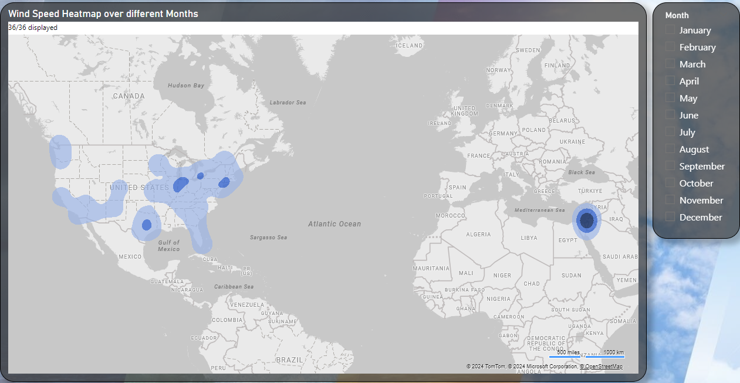

**14. Temperature-Humidity Analysis**

* **Insight**: This analysis provides a comprehensive view of how temperature and humidity interact in different climates. For instance, coastal cities like Tel Aviv maintain relatively stable temperature-humidity values due to maritime influence, while inland cities like Denver experience wider variability. Such insights can guide agricultural practices or HVAC system designs tailored to specific climates.

# EDA PROBLEM STATEMENTS

Problem 1:

Are there any countries with cities located at extreme latitudes, and how might this impact their climate?

Following cities are located at extreme Latitude:

Vancouver, Seattle, Portland and Montreal

Since these cities are located at extreme north latitudes, the temperature drops as we move further north.

SELECT

ca.City, ca.Latitude, avg(ta.avg_temperature), avg(ha.avg_humidity),

avg(pa.avg_pressure)

FROM

city_attributes ca

JOIN

shortened_temperature ta ON ca.City = ta.city

JOIN

shortened_humidity ha ON ca.City = ha.city

JOIN

shortened_pressure pa ON ca.City = pa.city

WHERE ca.Latitude > 45

GROUP BY 1,2

ORDER BY 2 DESC;

Problem 2:

Can you identify any clusters of cities with similar latitude and longitude values? What factors might explain these clusters?

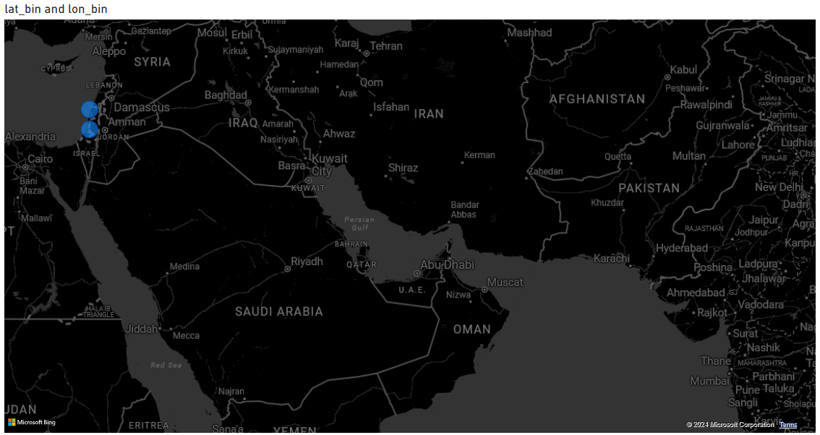

Following cities are in close proximity:

Jerusalem, Tel Aviv District, Haifa and Nahariyya

These cities belong to the following Lat-Lon bin:

|  |  |
| --- | --- |
| **lat_bin** | **lon_bin** |
| 32 | 35 |
| 33 | 35 |

All of the cities are in Israel

WITH latitude_longitude_bins AS (

SELECT

City,

ROUND(Latitude, 0.01) AS lat_bin, -- change the round value to widen or shorten the cluster

ROUND(Longitude, 0.01) AS lon_bin , -- change the round value to widen or shorten the cluster

FROM

city_attributes

)

SELECT

lat_bin,

lon_bin,

COUNT(City) AS city_count,

GROUP_CONCAT(City) AS cities_in_cluster

FROM

latitude_longitude_bins

GROUP BY

lat_bin, lon_bin

HAVING

city_count > 1 -- Only consider clusters with more than 1 city

ORDER BY

city_count DESC;

Problem 3:

Are there any correlations between a city's geographical location (latitude and longitude) and its weather attributes, such as temperature or humidity?

As the Latitude increases the temperature decreases

Select

ca.City

ca.Latitude,

ca.Longitude,

AVG(t.temperature) as avg_temp,

stddev(t.temperature) as temp_stddev

FROM

temperature_unpivoted t

JOIN

city_attributes ca ON t.city=ca.City

group by

1,2,3;

Problem 4:

Identify the top three cities with the most frequent occurrence of rainy weather based on weather descriptions. What are the seasonal patterns?

|  |  |  |  |  |  |  |  |  |  |
| --- | --- | --- | --- | --- | --- | --- | --- | --- | --- |
| **Count of Active months** |  |  |  |  | |  |  | |  |
| **Row Labels** | **1** | | | | **2** | | | **3** | | | **4** | **6** | **10** | **11** | **12** |
| Portland | 1 | | | | 1 | | | 1 | | | 1 |  | 1 | 1 | 1 |
| Seattle | 1 | | | | 1 | | | 1 | | | 1 |  | 1 | 1 | 1 |
| Vancouver |  | | | | 1 | | | 1 | | | 1 | 1 | 1 |  | 1 |
| **Grand Total** | **2** | | | | **3** | | | **3** | | | **3** | **1** | **3** | **2** | **3** |

The top 3 cities have these months in common in terms of high instances of rain:

*Feb, Mar, April, Oct and Dec*

WITH rainy_weather AS (

SELECT

City,

EXTRACT(MONTH FROM datetime) AS month,

COUNT(*) AS rainy_days

FROM

weather_description_unpivoted

WHERE

LOWER(weather_description) LIKE '%rain%'

GROUP BY

City, EXTRACT(MONTH FROM datetime)

),

city_rain_totals AS (

SELECT

City,

SUM(rainy_days) AS total_rainy_days,

AVG(rainy_days) AS avg_rainy_days

FROM

rainy_weather

GROUP BY

City

),

rainy_weather_filtered AS (

SELECT

rw.City,

rw.month,

rw.rainy_days,

ct.total_rainy_days

FROM

rainy_weather rw

JOIN

city_rain_totals ct ON rw.City = ct.City

WHERE

rw.rainy_days > ct.avg_rainy_days

),

top_cities AS (

SELECT

City

FROM

city_rain_totals

ORDER BY

total_rainy_days DESC

LIMIT 3

)

SELECT

rwf.City,

rwf.total_rainy_days,

rwf.month,

rwf.rainy_days

FROM

rainy_weather_filtered rwf

JOIN

top_cities tc ON rwf.City = tc.City

ORDER BY

rwf.City, rwf.month;

Problem 5:

Is there a correlation between humidity levels and air pressure? How might this relationship affect weather conditions?

|  |  |
| --- | --- |
| **# city** | **correlation_coefficient** |
| Las Vegas | 0.6 |
| Phoenix | 0.59 |
| Beersheba | 0.57 |
| Chicago | 0.56 |
| Portland | 0.55 |
| Eilat | 0.49 |
| Boston | 0.4 |
| Detroit | 0.38 |
| Dallas | 0.38 |
| Minneapolis | 0.35 |
| Toronto | 0.29 |
| Vancouver | 0.16 |
| Tel Aviv District | 0.12 |
| Jerusalem | 0.1 |
| Montreal | -0.02 |
| Denver | -0.02 |
| Houston | -0.03 |
| San Antonio | -0.03 |
| Indianapolis | -0.03 |
| Seattle | -0.05 |
| Philadelphia | -0.06 |
| Jacksonville | -0.07 |
| Albuquerque | -0.12 |
| Pittsburgh | -0.14 |
| Nahariyya | -0.23 |
| Miami | -0.28 |
| Haifa | -0.28 |
| San Francisco | -0.33 |
| Saint Louis | -0.33 |
| Kansas City | -0.37 |
| Atlanta | -0.4 |
| New York | -0.42 |
| Los Angeles | -0.44 |
| Charlotte | -0.45 |
| Nashville | -0.53 |
| San Diego | -0.65 |

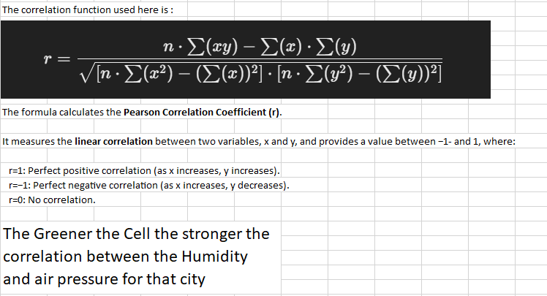

WITH summarized_data AS (

SELECT

h.city,

h.avg_humidity,

p.avg_pressure

FROM

shortened_humidity h

JOIN

shortened_pressure p ON h.city = p.city AND h.month = p.month

),

city_correlation AS (

SELECT

city,

COUNT(*) AS n,

SUM(avg_humidity) AS sum_humidity,

SUM(avg_pressure) AS sum_pressure,

SUM(avg_humidity * avg_pressure) AS sum_humidity_pressure,

SUM(avg_humidity * avg_humidity) AS sum_humidity_squared,

SUM(avg_pressure * avg_pressure) AS sum_pressure_squared

FROM

summarized_data

GROUP BY

city

)

SELECT

city,

ROUND(

(n * sum_humidity_pressure - sum_humidity * sum_pressure) /

SQRT(

(n * sum_humidity_squared - POW(sum_humidity, 2)) *

(n * sum_pressure_squared - POW(sum_pressure, 2))

),

2

) AS correlation_coefficient

FROM

city_correlation

ORDER BY

correlation_coefficient DESC;

Problem 6:

Are there any countries with cities located at extreme latitudes, and how might this impact their climate?

|  |  |
| --- | --- |
| **# city** | **wind_temp_correlation** |
| Vancouver | 0.96 |
| Portland | 0.93 |
| San Francisco | 0.91 |
| San Diego | 0.89 |
| Los Angeles | 0.85 |
| Tel Aviv District | 0.79 |
| Haifa | 0.79 |
| Seattle | 0.78 |
| Nahariyya | 0.76 |
| Boston | -0.48 |
| Jacksonville | -0.5 |
| Miami | -0.78 |

DARK GREEN CELL INDICATE STRONG CORRELATION BETWEEN WIND DIRECTION AND TEMPERATURE

WITH summarized_data AS (

SELECT

h.city,

h.avg_humidity,

p.avg_pressure

FROM

shortened_humidity h

JOIN

shortened_pressure p ON h.city = p.city AND h.month = p.month

),

city_correlation AS (

SELECT

city,

COUNT(*) AS n,

SUM(avg_humidity) AS sum_humidity,

SUM(avg_pressure) AS sum_pressure,

SUM(avg_humidity * avg_pressure) AS sum_humidity_pressure,

SUM(avg_humidity * avg_humidity) AS sum_humidity_squared,

SUM(avg_pressure * avg_pressure) AS sum_pressure_squared

FROM

summarized_data

GROUP BY

city

)

SELECT

city,

ROUND(

(n * sum_humidity_pressure - sum_humidity * sum_pressure) /

SQRT(

(n * sum_humidity_squared - POW(sum_humidity, 2)) *

(n * sum_pressure_squared - POW(sum_pressure, 2))

),

2

) AS correlation_coefficient

FROM

city_correlation

ORDER BY

correlation_coefficient DESC;

Problem 7:

Are there specific months when cities experience significant temperature fluctuations? What might explain these variations?

**Winter (High Variability: December–February)**:

* **Cold Fronts**: Frequent passage of cold fronts can lead to abrupt temperature swings.
* **Latitude Differences**: Northern cities experience stronger variability due to polar air masses.

**Summer (Low Variability: June–August)**:

* **Stable Patterns**: Summer is typically dominated by stable high-pressure systems, reducing daily fluctuations.

**Transition Seasons (Spring and Fall)**:

* Cities at different latitudes may experience fluctuations due to varying onset of seasonal changes.
* Oceanic influences near coastal cities stabilize temperatures compared to inland cities.

WITH monthly_temperature_stats AS (

SELECT

city,

EXTRACT(MONTH FROM datetime) AS month,

AVG(temperature) AS avg_temperature,

STDDEV(temperature) AS temp_fluctuation

FROM

temperature_unpivoted

GROUP BY

city, EXTRACT(MONTH FROM datetime)

)

SELECT

month,

ROUND(AVG(temp_fluctuation), 2) AS avg_temp_fluctuation,

COUNT(DISTINCT city) AS cities_analyzed

FROM

monthly_temperature_stats

GROUP BY

month

ORDER BY

avg_temp_fluctuation DESC;

Problem 8:

Identify periods of extreme weather events, such as storms or heatwaves, by analyzing the time-based data. What patterns emerge?

Extreme occur mostly during the month of Dec, Jan, April  
Which means that the weather extreme events mostly occur during Winter and Transition Seasons.

The year 2015 experienced the most amount of Extreme events.

WITH extreme_weather_events AS (

SELECT

city,

datetime,

weather_description

FROM

weather_description_unpivoted

WHERE

weather_description LIKE '%thunderstorm%' -- Thunderstorm conditions

OR weather_description LIKE '%heavy rain%' -- Heavy rain conditions

OR weather_description LIKE '%rain%' -- General rain conditions

OR weather_description LIKE '%snow%' -- Snow conditions

OR weather_description LIKE '%tornado%' -- Tornado conditions

OR weather_description LIKE '%hurricane%' -- Hurricane-related events, if applicable

OR weather_description LIKE '%squalls%' -- Squalls

OR weather_description LIKE '%volcanic ash%' -- Volcanic ash

OR weather_description LIKE '%freezing rain%' -- Freezing rain

)

-- Aggregating extreme weather events by city and date

SELECT

city,

DATE(datetime) AS date,

COUNT(*) AS extreme_weather_count

FROM

extreme_weather_events

GROUP BY

city, DATE(datetime)

ORDER BY

2 DESC;

Problem 9:

Are there any notable differences in temperature trends between northern and southern hemisphere cities over months? How do they relate to seasons?

The cities in northern hemisphere experience less temperature weathers compared to southern hemisphere

WITH hemisphere_cities AS (

SELECT

ca.city,

latitude,

avg_temperature, -- Already aggregated temperature by city and month

month

FROM

shortened_temperature st

JOIN

city_attributes ca ON st.city = ca.city

WHERE

ca.latitude > 37.511965 -- Northern Hemisphere cities (latitude > median)

OR

ca.latitude <= 37.511965 -- Southern Hemisphere cities (latitude <= median)

)

SELECT

CASE

WHEN latitude > 37.511965 THEN 'Northern Hemisphere'

ELSE 'Southern Hemisphere'

END AS hemisphere,

month,

AVG(avg_temperature) AS avg_temperature

FROM

hemisphere_cities

GROUP BY

hemisphere, month

ORDER BY

hemisphere, month;

Problem 10:

What are the consequences of prolonged periods of extreme cold or heat in specific cities? How do residents adapt to such conditions?

**Impacts:**

1. **Health:**
   * Heat: Risk of dehydration, heatstroke, and worsened heart conditions, especially for the elderly and children.
   * Cold: Increased chances of hypothermia, frostbite, and respiratory issues.
2. **Infrastructure:**
   * Heat: Power outages, damaged roads, and wildfire risks.
   * Cold: Frozen pipes, broken power lines, and hazardous roads.
3. **Economic:**
   * Heat: Crop failures, reduced productivity, and a dip in tourism.
   * Cold: Higher heating costs, transport disruptions, and economic slowdowns.
4. **Environment:**
   * Heat: Ecosystem stress, droughts, and species migration.
   * Cold: Disruption in wildlife behavior and plant growth.

**Adaptations:**

* **Hot Climates:**
  + Cooling systems, breathable clothing, hydration, and adjusted schedules.
* **Cold Climates:**
  + Heating, layered clothing, hot food, and snowstorm preparedness.

WITH extreme_weather AS (

SELECT

ta.city,

ta.temperature,

ta.datetime,

EXTRACT(MONTH FROM ta.datetime) AS month

FROM

temperature_unpivoted ta

WHERE

ta.temperature >= 308.15 -- Extreme heat: temperature >= 308.15 K (35°C)

OR

ta.temperature <= 273.15 -- Extreme cold: temperature <= 273.15 K (0°C)

)

SELECT

city,

SUM(CASE WHEN temperature >= 308.15 THEN 1 ELSE 0 END) AS extreme_heat_events,

SUM(CASE WHEN temperature <= 273.15 THEN 1 ELSE 0 END) AS extreme_cold_events

FROM

extreme_weather

GROUP BY

city

Problem 11:

Investigate whether temperature anomalies (unusual deviations from the norm) coincide with certain events or environmental factors in specific cities.

**Temperature anomalies** might be tied to extreme weather events (such as heatwaves, cold snaps, or storms). You can look for correlations between temperature anomalies and weather events.

High anomalies may coincide with **heatwaves**, while low anomalies could be associated with **cold fronts**, **snowstorms**, or **winter storms**.

Problem 12:

WITH temperature_norms AS (

-- Calculate average temperature and standard deviation for each city per month

SELECT

city,

EXTRACT(MONTH FROM datetime) AS month,

AVG(temperature) AS avg_temperature,

STDDEV(temperature) AS stddev_temperature

FROM

temperature_unpivoted

GROUP BY

city, EXTRACT(MONTH FROM datetime)

),

temperature_anomalies AS (

-- Identify temperature anomalies (temperature > 1.5 stddev from the mean)

SELECT

ta.city,

ta.temperature,

tn.avg_temperature,

CASE

WHEN ta.temperature > (tn.avg_temperature + 1.5 * tn.stddev_temperature) THEN 'High Anomaly'

WHEN ta.temperature < (tn.avg_temperature - 1.5 * tn.stddev_temperature) THEN 'Low Anomaly'

ELSE 'Normal'

END AS temperature_status

FROM

temperature_unpivoted ta

JOIN

temperature_norms tn ON ta.city = tn.city AND EXTRACT(MONTH FROM ta.datetime) = tn.month

)

SELECT

city,

ROUND(AVG(avg_temperature), 2) AS avg_city_temperature,

COUNT(CASE WHEN temperature_status IN ('High Anomaly', 'Low Anomaly') THEN 1 END) AS anomaly_count

FROM

temperature_anomalies

WHERE

temperature_status IN ('High Anomaly', 'Low Anomaly')

GROUP BY

city

ORDER BY

anomaly_count DESC;

Analyze the impact of temperature on energy consumption patterns in cities. Are there noticeable trends or correlations?

The Cities with extreme heat or cold conditions are tend to use more power than the cities with normal condition.  
  
Since, extreme weather requires technologies like Cooler/AC(for extreme heat) and Heaters (for extreme cold). Thus, the power consumption in that city would be significantly higher.

Top months for extreme cold (power consumption by heater like appliances): Jan, Feb, Mar and Dec

Top months for extreme heat (power consumption by A/C like appliances): Jun, Jul, Aug

SELECT

city,

month,

avg_temperature,

CASE

WHEN avg_temperature >= 303.15 THEN 'Extreme Heat' -- 30°C in Kelvin

WHEN avg_temperature <= 273.15 THEN 'Extreme Cold' -- 0°C in Kelvin

ELSE 'Normal'

END AS temperature_flag

FROM

shortened_temperature -- Using the existing shortened_temperature view

ORDER BY

city, month;

Problem 13:

How do specific wind patterns impact air quality and pollution dispersion in urban areas? Analyze wind Speed data for insights.

Cities with slower wind speeds tend to face challenges in dispersing pollutants, leading to their accumulation. This phenomenon can result in the following impacts:

**Key Impacts:**

1. **Deteriorated Air Quality:**
   * Limited wind movement allows pollutants like particulate matter (PM2.5, PM10), nitrogen oxides, and sulfur dioxide to remain suspended in the air for longer durations.
   * Increased risk of smog formation, particularly in urban areas with high vehicle emissions and industrial activity.
2. **Health Concerns:**
   * Poor air quality aggravates respiratory issues such as asthma, bronchitis, and other lung diseases.
   * Long-term exposure to stagnant pollutants can lead to cardiovascular problems and reduced life expectancy.
3. **Urban Heat Island Effect:**
   * Accumulated pollutants can trap heat, exacerbating temperature rises in cities, especially during the summer.
4. **Visibility Issues:**
   * Pollution accumulation reduces visibility, affecting transportation safety, especially during peak hours or in areas with high traffic density.

**Mitigation Strategies:**

1. **Urban Planning:**
   * Design green spaces and wind corridors to facilitate air circulation.
2. **Pollution Control Measures:**
   * Promote cleaner technologies, enforce emission norms, and adopt renewable energy sources.
3. **Community Awareness:**
   * Encourage reduced vehicle usage and educate the public about pollution's health impacts.

SELECT

st.city,

st.month,

avg_temperature,

CASE

WHEN avg_temperature >= 308.15 THEN 'Extreme Heat'

WHEN avg_temperature <= 273.15 THEN 'Extreme Cold'

ELSE 'Normal'

END AS temperature_category,

avg_wind_speed,

CASE

WHEN avg_wind_speed <= 2.49 THEN 'Slow'

WHEN avg_wind_speed > 2.49 AND avg_wind_speed <= 3.58 THEN 'Normal'

WHEN avg_wind_speed > 3.58 THEN 'Fast'

ELSE 'Unknown'

END AS wind_speed_category

FROM

shortened_temperature st

JOIN

shortened_wind_speed sws ON st.city = sws.city AND st.month = sws.month

ORDER BY

city, month;

Problem 14:

Identify cities prone to strong winds and the potential consequences, such as increased risk of natural disasters or challenges for transportation.

Miami Has experienced the most no. of wind related disasters.

The following cities have higher risk of natural disasters (e.g., Storms, Hurricanes):

Chicago, Dallas, Eilat, Haifa, Minneapolis, Montreal

SELECT

ws.city,

ws.month,

ws.avg_wind_speed,

CASE

WHEN ws.avg_wind_speed > 3.58 THEN 'Prone to Strong Winds'

ELSE 'Normal Winds'

END AS wind_risk_category,

CASE

WHEN ws.avg_wind_speed > 4 THEN 'Higher Risk of Natural Disasters (e.g., Storms, Hurricanes)'

WHEN ws.avg_wind_speed BETWEEN 3 AND 4 THEN 'Increased Transportation Challenges'

ELSE 'Normal Conditions'

END AS potential_consequences,

COUNT(CASE

WHEN wd.weather_description LIKE '%storm%'

OR wd.weather_description LIKE '%hurricane%'

OR wd.weather_description LIKE '%tornado%'

OR wd.weather_description LIKE '%squall%'

THEN 1

ELSE NULL

END) AS wind_related_disasters

FROM

shortened_wind_speed ws

LEFT JOIN

weather_description_unpivoted wd ON ws.city = wd.city AND ws.month = EXTRACT(MONTH FROM wd.datetime)

GROUP BY

ws.city, ws.month, ws.avg_wind_speed

ORDER BY

ws.avg_wind_speed DESC;

Problem 15:

Explore whether wind speed and direction influence the frequency and severity of weather-related events (e.g., hurricanes, storms) in coastal cities.

There is very little influence of Wind speed and direction in the city over the frequency or severity of weather-related events.

The severe weather-related events might emerge afar from the cities and then affect them, making it challenging to directly attribute their frequency or severity to local wind speed and direction. Instead, these events are often influenced by broader meteorological systems, such as cyclones, hurricanes, or atmospheric pressure changes, which develop over larger regions and then move towards the urban areas.

This implies that while localized wind conditions may not play a significant role in initiating such events, cities can still experience their impacts depending on the path and intensity of the broader weather system.

WITH coastal_cities AS (

SELECT 'Vancouver' AS city

UNION ALL SELECT 'Portland'

UNION ALL SELECT 'San Francisco'

UNION ALL SELECT 'Seattle'

UNION ALL SELECT 'Los Angeles'

UNION ALL SELECT 'San Diego'

UNION ALL SELECT 'Miami'

UNION ALL SELECT 'Toronto'

UNION ALL SELECT 'Montreal'

UNION ALL SELECT 'Beersheba'

UNION ALL SELECT 'Tel Aviv District'

UNION ALL SELECT 'Eilat'

UNION ALL SELECT 'Haifa'

UNION ALL SELECT 'Nahariyya'

UNION ALL SELECT 'Jerusalem'

),

weather_event AS (

SELECT

city,

COUNT(*) AS event_count

FROM

weather_description_unpivoted

WHERE

LOWER(weather_description) LIKE '%storm%'

OR LOWER(weather_description) LIKE '%hurricane%'

OR LOWER(weather_description) LIKE '%tornado%'

OR LOWER(weather_description) LIKE '%squall%'

OR LOWER(weather_description) LIKE '%wind%'

GROUP BY

city

),

average_wind_speed AS (

SELECT

city,

AVG(wind_speed) AS avg_wind_speed

FROM

wind_speed_unpivoted

GROUP BY

city

),

average_wind_direction AS (

SELECT

city,

AVG(wind_direction) AS avg_wind_direction

FROM

wind_direction_unpivoted

GROUP BY

city

)

SELECT

c.city,

COALESCE(aws.avg_wind_speed, 0) AS avg_wind_speed,

COALESCE(awd.avg_wind_direction, 0) AS avg_wind_direction,

COALESCE(we.event_count, 0) AS event_count

FROM

coastal_cities c

LEFT JOIN

average_wind_speed aws ON c.city = aws.city

LEFT JOIN

average_wind_direction awd ON c.city = awd.city

LEFT JOIN

weather_event we ON c.city = we.city

ORDER BY

avg_wind_speed DESC;

# REPORT ENDED